### **Part (a): Operations on Employee List**

**Code Explanation:**

1. **List Slicing**: We split the list of 10 employee names into two sub-lists, each containing 5 names.
2. **Adding and Deleting Elements**: We add a new employee to subList2 and remove the second employee from subList1.
3. **Joining Lists**: We merge subList1 and subList2 to form a single list.
4. **List Updating**: We update each salary in salaryList by giving a 4% raise.
5. **List Sorting**: We sort the updated salary list.
6. **Showing the Top Three Salaries**: We extract and display the top 3 salaries.

**Code:**

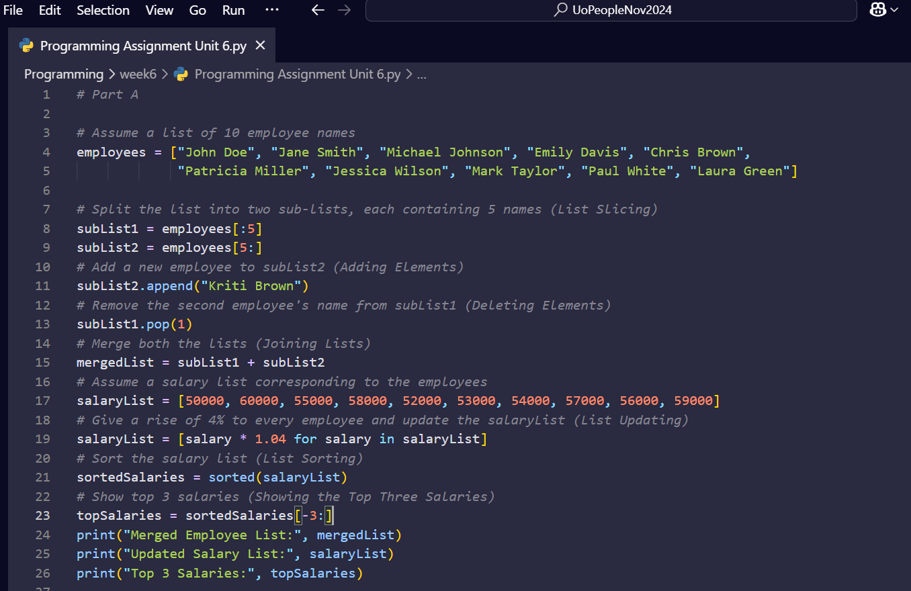

**Output Explanation:**

1. **Merged Employee List:**
   * **After splitting, merging, and modifying the lists, the final merged list is:**
   * 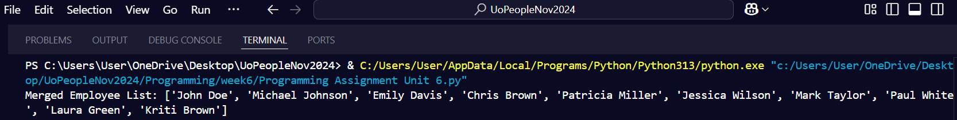
   * **This output shows the list after the new employee "Kriti Brown" is added to subList2 and the second employee ("Jane Smith") is removed from subList1.**

**2. Updated Salary List:**

* **Each salary is increased by 4%, resulting in:**
  + 
  + **This output reflects the updated salaries after applying a 4% raise to each original salary.**

**3. Top 3 Salaries:**

* **After sorting the updated salaries, the top 3 highest salaries are:**
* 
* **This output shows the highest three salaries after sorting the updated list.**

### **References:**

* **Downey, A. (2015). *Think Python: How to think like a computer scientist*. O'Reilly Media.**
* **Matthes, E. (2019). *Python Crash Course: A hands-on, project-based introduction to programming* (2nd ed.). No Starch Press.**

**According to Downey (2015), lists in Python are mutable sequences, which means that their elements can be changed. This property is crucial when performing operations like updating the salary list and merging employee lists. As Matthes (2019) describes, Python's list methods, such as append, pop, and slicing, are powerful tools for manipulating and managing lists efficiently.**

### **Part (b): Convert Sentence into Wordlist and Reverse**

**Code Explanation:**

1. **String-to-List Conversion: We split the sentence into words using the split method.**
2. **List Reversal: We reverse the list of words using slicing [::-1].**

**Code:**

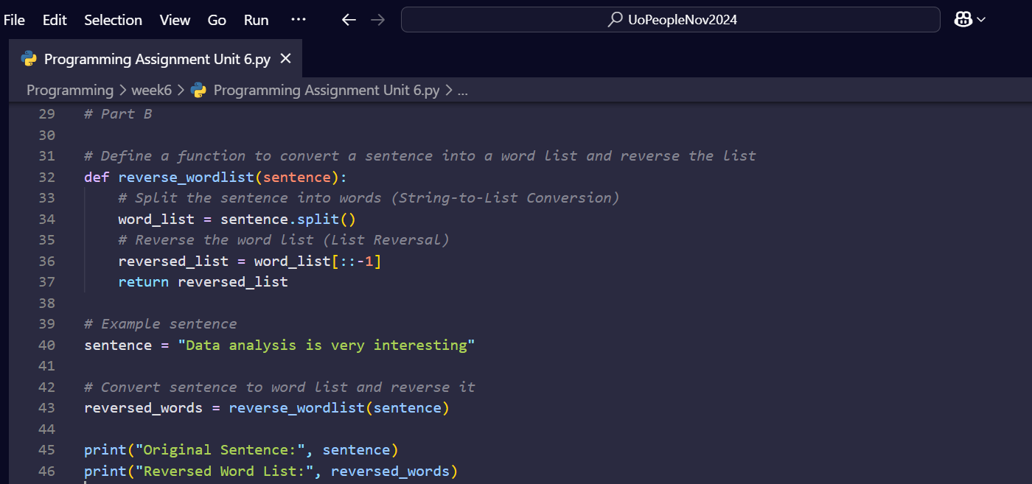

**Output Explanation:**

1. **Original Sentence:**

**The sentence we started with is:  
 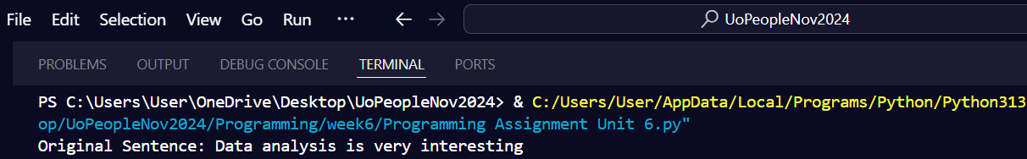**

1. **Reversed Word List:**

**After splitting and reversing, the list of words is:**

* + 
  + **This output correctly shows the reversed order of words in the sentence.**

**According to Matthes (2019), string manipulation techniques such as splitting and reversing are fundamental for text processing tasks in Python. These operations demonstrate how to break a sentence into words and manipulate the word order efficiently.**

### **References:**

* **Downey, A. (2015). *Think Python: How to think like a computer scientist*. O'Reilly Media.**
* **Matthes, E. (2019). *Python Crash Course: A hands-on, project-based introduction to programming* (2nd ed.). No Starch Press.**